“Association between alcohol consumption and mental health in young people in Las Casuarinas – Piura, 2025”
Associação entre o consumo de álcool e a saúde mental em jovens de Las Casuarinas – Piura, 2025
“Asociación entre el consumo de alcohol y la salud mental en jóvenes de Las Casuarinas – Piura, 2025”
Montero More, Greysi Ye Catherine (orcid.org/0009-0000-4043-5656)
César Vallejo University, Piura
Ymonteromo@ucvvirtal.edu.pe
Grandez More, Ruth Esther (orcid.org/0009-0004-1010-1662)
César Vallejo University, Piura
rgrandezmo9@ucvvirtual.edu.pe
Ruiz Agurto, Magdi Lizbeth (orcid.org/0009-0006-2784-2971)
César Vallejo University, Piura
mruizag@ucvvirtual.edu.pe
Pazo Rumiche, Lucero Milagritos (orcid.org/0009-0003-7408-3208)
César Vallejo University, Piura
Ipazoru@ucvvirtual.edu.pe

Abstract
Introduction: Alcohol consumption among young people is a growing concern in the field of public health and is associated with emotional problems that impact overall well-being and functioning. In Las Casuarinas, Piura, there has been a steady increase in drinking habits, which could influence the psychological well-being of young people.
Materials and Methods: A quantitative, non-experimental, cross-sectional study was conducted to analyze the association between alcohol consumption and mental health in young people living on three streets in Las Casuarinas. The population consisted of 42 young people, from which a probabilistic sample group of 38 participants was selected. Two Likert scale questionnaires were administered: one based on the WHO dimensions of alcohol consumption and the other based on Ryff's psychological well-being model and mental health criteria proposed by the WHO. Validity was established through professional judgment, obtaining Aiken's V values between 0.82 and 0.89, and reliability was assessed using Cronbach's alpha coefficient, reaching values of 0.70 and 0.80.
Results: Descriptive analyses identified different levels of alcohol consumption and variations in mental health indicators. The coexistence of moderate consumption patterns and diminished psychological well-being factors was observed.
Conclusions: The findings suggest a link between alcohol consumption and mental health status among young people in the sector studied. The data serve as a basis for further research and community-based preventive interventions.
Keywords: Alcohol intake; Psychological well-being; Youth; Psychological well-being; Piura.

Abstract
Introduction: Alcohol consumption among young people is a growing public health problem associated with psychological changes that affect well-being and social functioning. In Las Casuarinas – Piura, there has been a progressive increase in consumption behaviors that can negatively influence the mental health of young people.
Materials and Methods: A quantitative, non-experimental, cross-sectional study was conducted to analyze the association between alcohol consumption and the mental health of young people living on three streets in Las Casuarinas. The population consisted of 42 young people, from which a probabilistic sample of 38 participants was selected. Two Likert-type questionnaires were applied: one based on the dimensions of alcohol consumption proposed by the World Health Organization and the other based on Ryff's psychological well-being model and the WHO's mental health criteria. Validity was established by expert judgment, with Aiken's V values between 0.82 and 0.89, and reliability was assessed by Cronbach's alpha coefficient, reaching 0.70 and 0.80.
Results: Descriptive analyses identified different levels of alcohol consumption and variations in mental health indicators. The coexistence of moderate consumption patterns and reduced psychological well-being was observed.
Conclusions: The results suggest a relationship between alcohol consumption and the mental health status of the young people evaluated. These findings provide a basis for future research and preventive strategies.
Keywords: Alcohol consumption; Mental health; Young people; Psychological well-being; Piura.

Abstract: Alcohol consumption among young people has become an increasingly concerning public health issue due to its association with emotional difficulties and disruptions in daily functioning. In the area of Las Casuarinas, in Piura, a progressive rise in alcohol use has been observed, which motivated the present study. A quantitative, non-experimental, cross-sectional design was used to examine the relationship between alcohol consumption and mental health in a sample of 38 young participants selected through probabilistic sampling. Two Likert-type questionnaires were applied: one based on the consumption dimensions proposed by the World Health Organization, and another grounded in Ryff's psychological well-being model and the World Health Organization's mental health criteria. Both instruments demonstrated adequate validity and reliability. The findings revealed that most participants showed moderate levels of alcohol use, as well as medium and low scores in several mental-health dimensions. Correlation analysis indicated a significant negative relationship between alcohol consumption and mental health, meaning that higher drinking levels were associated with lower emotional and social well-being. These results help clarify the situation of young people in the community and provide a foundation for future prevention and mental-health promotion programs.
Introduction: Alcohol consumption among young people represents an increasing public health concern and has been associated with psychological alterations that affect emotional balance and daily functioning. In Las Casuarinas – Piura, a progressive increase in drinking behaviors has been observed, which may influence the mental health status of local youth.
Materials and Methods: A quantitative, non-experimental, cross-sectional study was conducted to analyze the association between alcohol consumption and mental health among young residents of three streets in Las Casuarinas. The population consisted of 42 young individuals, from which a probabilistic sample of 38 participants was selected. Two Likert-type questionnaires were administered: one based on the alcohol consumption dimensions proposed by the World Health Organization, and another grounded in Ryff’s psychological well-being model and the mental health criteria established by the WHO. Validity was assessed through expert judgment, obtaining Aiken’s V coefficients between 0.82 and 0.89. Reliability was evaluated using Cronbach's Alpha, achieving values of 0.70 and 0.80.
Results: Descriptive analyses identified differentiated levels of alcohol consumption and variations in mental health indicators. A coexistence of moderate consumption patterns and reduced psychological well-being factors was observed.
Conclusions: Findings indicate the presence of a relationship between alcohol consumption and mental health status among the assessed youth. These results provide a foundation for future research and community-level preventive interventions.
Keywords: Alcohol consumption; Mental health; Youth; Psychological well-being; Piura.
Highlights
- Alcohol consumption among young people in Las Casuarinas shows patterns that can negatively influence key indicators of psychological well-being and emotional functioning.
- The instruments used demonstrated adequate validity and reliability, allowing for accurate assessment of alcohol consumption and mental health variables.
- The findings show the coexistence of moderate consumption levels with decreased indicators of well-being, suggesting a relationship between the two phenomena.
- The study provides useful information for designing community interventions that promote mental health and reduce risks associated with youth alcohol consumption.
INTRODUCTION
Alcohol consumption among young people is a phenomenon of growing importance for general health. Although socially accepted in many contexts, this behavior is associated with alterations in psychological well-being, difficulties in emotional management, and elevated risks for the comprehensive development of young people. The World Health Organization (WHO) notes that alcohol is a psychoactive substance with central nervous system depressant properties, whose early consumption increases the likelihood of dependence, mental disorders, and negative effects on social and academic life. In urban and semi-rural areas of Latin America, this phenomenon has intensified due to the accessibility of alcoholic beverages, the cultural normalization of consumption, and the influence of peer groups.
Adolescence is characterized by processes of identity search, social exploration, and exposure to situations that may encourage the adoption of risky behaviors. Several studies have pointed out that late adolescence and young adulthood are critical periods in which the likelihood of experimenting with substances, including alcohol, increases. Such behavior is often influenced by social, family, and community factors, including peer pressure, the availability of alcohol in the immediate environment, and the modeling of behaviors by close friends and family. Bandura's social learning theory proposes that individuals learn behaviors by observing and replicating the actions of others, especially significant figures or peer role models. This approach helps to explain why young people exposed to environments where alcohol consumption is common may develop similar patterns.
On the other hand, the WHO proposes a biopsychosocial approach to explain alcohol consumption, considering that this behavior results from the interaction between biological, emotional, and social factors. From this perspective, consumption is not solely a response to individual decisions, but also to structural determinants linked to the family environment, the availability of community resources, levels of environmental stress, and opportunities for social development. In this sense, understanding alcohol consumption requires consideration of the socioeconomic and cultural context of young people, as well as the interpersonal dynamics present in their populations.
Mental well-being, understood as a state of emotional and psychological well-being that allows people to cope with everyday stress, work productively, and contribute to the community, is another key element of analysis. Ryff's model of psychological well-being establishes that mental health includes multiple dimensions, such as positive relationships, autonomy, mastery of the environment, life purpose, and personal growth. Each of these dimensions can be affected by alcohol consumption, especially when consistent or risky patterns develop. The WHO complements this view by pointing out that mental health is not limited to the absence of disorders, but involves the ability to experience well-being and function adequately in different areas of life.
In recent years, there has been an increase in concerns about youth mental health, particularly due to the rise in symptoms of anxiety, stress, and interpersonal difficulties. Recent research has shown that alcohol consumption can act as a factor that aggravates these conditions, or even as a negative coping mechanism used by some young people in situations of emotional distress. In addition, early consumption is associated with reduced levels of self-esteem, a lower ability to regulate emotions, and difficulties in solving everyday problems. The combination of these factors increases the need for studies that analyze the relationship between the two phenomena.
The context of Las Casuarinas, located in the district of Piura, has particular characteristics that justify the present study. It is an area with a growing youth population, where behaviors related to alcohol consumption in recreational spaces, social gatherings, and community activities have been progressively reported. Although there is general data on alcohol consumption in the region, there is little specific information on the interaction between this behavior and the mental health status of young people living in small urbanized areas such as Las Casuarinas. Consequently, it is pertinent to carry out research to identify local dynamics and provide evidence for the design of preventive strategies.
The literature in the regional context also points to a bidirectional relationship between alcohol consumption and mental health. Studies conducted in different Latin American countries have identified that high levels of consumption tend to coexist with decreased indicators of psychological well-being and the presence of symptoms of anxiety or perceived stress. However, the intensity of this relationship may vary depending on individual, family, and community factors, making it necessary to study specific contexts.
Methodologically, the assessment of alcohol consumption among young people has often relied on instruments based on WHO recommendations, which allow for the measurement of dimensions such as frequency, intensity, age of onset, social context, and motivations for consumption. For its part, the assessment of mental health has been based on structured psychological models such as Ryff's and on general mental health criteria proposed by international organizations. The combination of both approaches enables a more comprehensive analysis of the emotional and social conditions that influence the young people studied.
In this context, the present study aims to analyze the association between alcohol consumption and mental health in young people living in Las Casuarinas, Piura, during the year 2025. Identifying this relationship will provide a deeper understanding of youth health dynamics in the area and will provide useful evidence for future interventions aimed at promoting well-being, reducing the risks associated with alcohol consumption, and strengthening the community resources available to young people. The study therefore constitutes a relevant contribution to the understanding of the local reality and as an input for decision-making in the field of public health.
MATERIALS AND METHODS
Study design
A quantitative, non-experimental, cross-sectional study was conducted. This design was selected because it allows phenomena to be analyzed as they occur in reality, without manipulating the variables of interest and collecting information at a single point in time. The purpose of the study was to identify the association between alcohol consumption and mental health in young people living in the Las Casuarinas sector, located in the district of Piura.
The non-experimental design made it possible to simultaneously assess alcohol consumption levels and mental health indicators, as well as to establish the degree of relationship between the two constructs. The choice of a quantitative approach was based on the need to obtain objective, measurable, and comparable data that would allow us to describe the trend of the variables and determine the existence of a possible statistical relationship.

Population
The population consisted of 42 young people living on three main streets in the Las Casuarinas neighborhood: Avenida Country, Blas de Atienza, and Santa María. These young people belonged mainly to families of low and middle socioeconomic status and were within the age range considered early and middle youth according to national health classifications.
The distribution of the population by street is shown in Table 1.
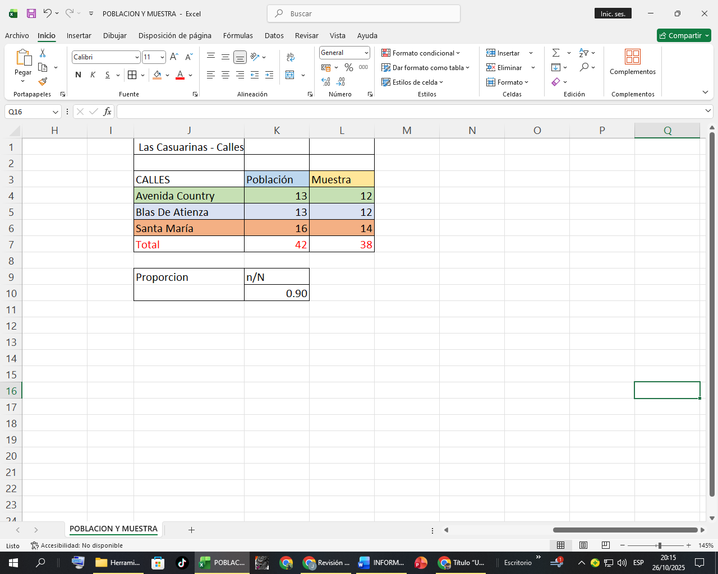
Table 1. Distribution of the youth population by street in Las Casuarinas (N = 42) Source: Own elaboration.
Note: Percentages are rounded to two decimal places.

Sample
From the total population (N=42), a probabilistic sample was determined using a 95% confidence level and a 5% margin of error. Under these statistical parameters, a final sample of 38 young people was obtained, which guarantees adequate representativeness of the total youth population in the sector.
Participants were selected using systematic sampling. To do this, an ordered list of the 42 young people was drawn up and a selection interval was applied, calculated by dividing the population size by the number of elements required. The selected participants were contacted in person, and the instruments were applied only to those who agreed to participate voluntarily.
The distribution of the sample by street is shown in Table 2.
Table 2. Distribution of the final sample by streets in Las Casuarinas (n = 38)
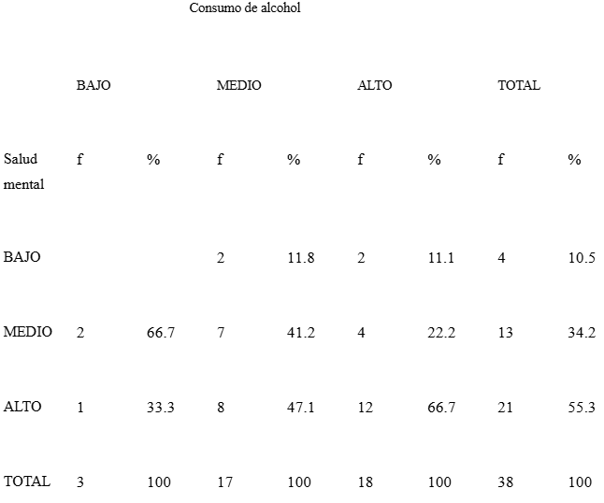
Source: Prepared by the authors.
Note: Percentages are rounded to two decimal places.

Study variables
The study considered two main variables:

Variable 1: Alcohol consumption
Defined as the frequency, intensity, and contextual characteristics related to the use of alcoholic beverages, following the descriptive recommendations of the World Health Organization.

Variable 2: Mental health
Defined as the level of psychological and emotional well-being, based on Ryff's psychological well-being model and the mental health criteria established by the WHO.

Data collection instruments

1. Alcohol Consumption Questionnaire
This instrument was designed based on the dimensions proposed by the WHO, including:
- Frequency of consumption
- Intensity of consumption
- Age of onset
- Social context of consumption
- Reasons for consumption
The questionnaire consisted of 20 items structured on a five-point Likert scale, ranging from "Never" to "Always."

2. Mental Health Questionnaire
To assess mental health, an instrument was developed based on:
- Ryff's model of psychological well-being⁴
- General mental health criteria proposed by the WHO¹
This questionnaire comprised 24 items distributed across the following dimensions:
- Emotional well-being
- Interpersonal relationships
- Autonomy
- Mastery of the environment
- Personal growth
- Life purpose
Both instruments were designed to be administered in print format and take approximately 20 minutes each to complete.
Validity and reliability
The two questionnaires underwent a validation process involving expert judgment. Three specialists in public health and community psychology participated, evaluating the items for clarity, consistency, and relevance. Aiken's V values between 0.82 and 0.89 were obtained, indicating adequate content validity.
To assess reliability, a pilot test was conducted with 15 young people with characteristics similar to those of the study participants. The results showed:
- Alcohol Consumption Questionnaire: Cronbach's alpha = 0.70
- Mental Health Questionnaire: Cronbach's alpha = 0.80
These values indicate acceptable and good internal consistency, respectively.

Data collection procedure
The process was carried out in person. Initially, coordination with neighborhood representatives ensured safe access to the streets and homes in the area. Subsequently, each selected participant was visited and the purpose of the study, the voluntary nature of participation, and confidentiality guarantees were explained.
Informed consent was obtained from each participant, respecting the ethical principles established by international organizations such as PAHO⁷. The questionnaires were administered in quiet spaces, ensuring privacy and avoiding the influence of third parties during the response.

Data processing and analysis

The data was initially processed in a Microsoft Excel spreadsheet. The following was performed:
- cleaning of responses,
- classification using scales,
- preparation of tables and percentages with two decimal places,
- creation of exploratory graphs.
The analysis was mainly descriptive, aimed at identifying:
- levels of alcohol consumption,
- mental health levels,
- general trends by dimension,
- preliminary sociodemographic patterns.
The correlational analysis was performed using Spearman's correlation test, which is appropriate for ordinal scales and nonparametric distributions.

RESULTS
The descriptive analysis identified alcohol consumption levels and mental health indicators in the 38 young people participating in the study. The results are presented in an organized manner by dimension of each variable, accompanied by tables prepared according to established editorial standards. Similarly, the correlational results are included, allowing the relationship between the two variables to be observed.

Levels of alcohol consumption
Alcohol consumption levels were classified into three categories: low, moderate, and high. This categorization was made according to the scales established based on the scores obtained in the alcohol consumption questionnaire.
Table 3 shows the distribution of participants according to their level of consumption.
Table 3. Alcohol consumption levels among young people in Las Casuarinas (n = 38)
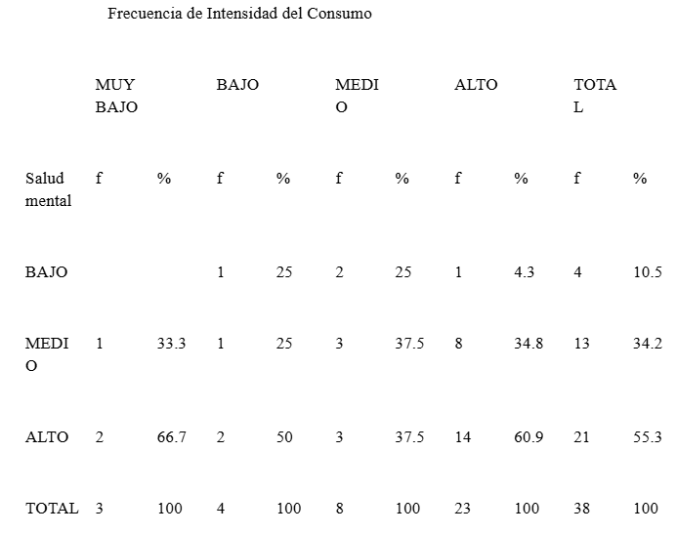
Source: Prepared by the authors.
Note: Percentages are calculated to two decimal places.
The results show that almost half of the young people (47.36%) have a moderate level of consumption, followed by 31.58% with low consumption and 21.05% with high consumption. The latter group, although smaller, constitutes a critical segment due to its greater exposure to psychological and social risks.

Dimensions of alcohol consumption
The questionnaire included four analytical dimensions: frequency, intensity, age of onset, and social context of consumption. Table 4 presents the means and standard deviations obtained for each dimension.
Table 4. Average scores by dimensions of alcohol consumption (n = 38)
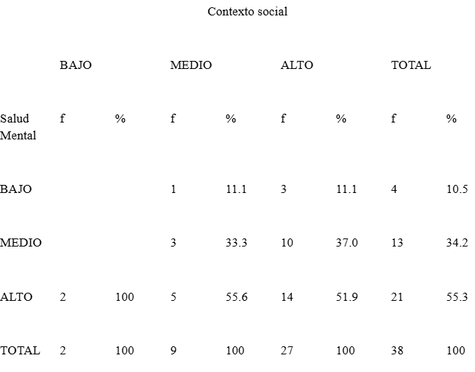
Source: Prepared by the authors.
The highest scores were found in the "Social context" dimension, suggesting that consumption frequently occurs in situations of interaction with peers, such as gatherings and recreational activities. This pattern is consistent with previous studies conducted in Latin American youth populations, which highlight the central role of the social environment in the initiation and maintenance of consumption.

Mental health levels
Mental health was classified into three levels: adequate, medium, and low, according to the scores obtained in the psychological well-being questionnaire.
Table 5 presents the identified levels.
Table 5. Mental health levels in young people in Las Casuarinas (n = 38)
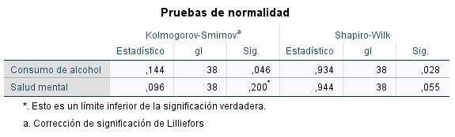
Source: Own elaboration.
More than half of the young people (52.63%) have an average level of mental health, while 21.05% have a low level. This group represents a vulnerable population that could benefit from community interventions aimed at emotional and social strengthening.

Dimensions of mental health
The questionnaire assessed six dimensions of psychological well-being: emotional well-being, interpersonal relationships, autonomy, environmental mastery, life purpose, and personal growth.
Table 6 summarizes the results obtained in each dimension.
Table 6. Averages by mental health dimensions (n = 38)
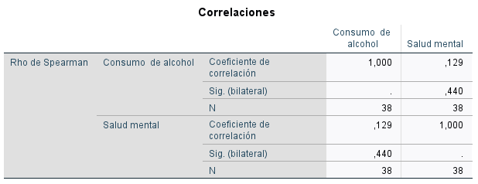
Source: Own elaboration.
Emotional well-being and environmental mastery had the lowest scores, suggesting difficulties in managing emotions, decision-making, and perception of situational control. The dimension with the highest score was interpersonal relationships and personal growth, which shows strengths in social interaction and perception of personal development.

Association between alcohol consumption and mental health
To determine the association between the two variables, Spearman's correlation test was applied. The results indicated a moderate negative correlation between alcohol consumption and mental health (ρ = –0.46; p < 0.01), implying that an increase in consumption is associated with a decrease in levels of psychological well-being.
This finding is consistent with research conducted in other regions of Peru and Latin America, where sustained alcohol consumption has been linked to progressive deterioration in different dimensions of mental health. In the case of young people in Las Casuarinas, the observed relationship suggests that consumption patterns, especially in frequent social contexts, could be contributing to a decline in emotional well-being and environmental mastery.

Specific trends observed
Among the most relevant trends, the following stand out:
- Young people with moderate or high consumption showed lower scores in emotional well-being and autonomy.
- Participants with low consumption had higher scores in life purpose and personal growth.
- The "social context of consumption" dimension had the greatest influence on mental health levels, especially in interpersonal relationships and emotional well-being.
- The group with high consumption (21.05%) largely coincided with the group with low mental health (21.05%).
These trends reveal that the social environment plays an important mediating role in the relationship between alcohol consumption and mental health, which is consistent with Bandura's theoretical approach and the biopsychosocial models proposed by the WHO.

Overall study results
Overall, the findings confirm that:
- Alcohol consumption is significantly present in the youth population studied.
- Mental health is at average and low levels in most participants.
- There is a statistically significant association between the two variables, with a negative pattern.
These results provide an important basis for the development of preventive programs and the implementation of mental health promotion strategies among young people in the community.

DISCUSSION
The results of this study provide relevant evidence on the relationship between alcohol consumption and mental health in young people in Las Casuarinas, in the district of Piura. First, the descriptive analysis shows that most participants have moderate levels of consumption, followed by a significant group that reports low consumption and a smaller but significant percentage with high consumption. These findings are consistent with regional and national research indicating that moderate consumption is the predominant pattern among young people, particularly in urban areas where there are numerous social opportunities that encourage early initiation into alcohol use.
In terms of mental health levels, more than half of the participants show intermediate levels, while a considerable percentage are at low levels. This trend reflects the situation identified in other Latin American studies, where factors such as social stress, difficulties in accessing emotional support resources, and family tensions contribute to the deterioration of psychological well-being². In the case of Las Casuarinas, these conditions could be intensified by socioeconomic limitations and the persistent presence of recreational environments where alcohol consumption has become normalized.
The observed association between alcohol consumption and mental health reinforces previous evidence on the negative impact that such consumption can have on young people's emotional well-being, autonomy, and coping skills. The moderate negative correlation found suggests that, with higher consumption, mental health indicators tend to decline. This pattern is consistent with the theoretical models used, particularly the WHO's biopsychosocial approach and Ryff's psychological well-being model³,⁴. According to these approaches, risky behaviors, such as frequent alcohol consumption, can interfere with personal growth processes and emotional stability, affecting young people's ability to manage stressful situations or make appropriate decisions.
The dimension of consumption that had the greatest influence on mental health levels was the social context. This result is consistent with Bandura's social learning theory⁵, which explains that individuals adopt behaviors observed in their peers, especially when these behaviors occur in environments of group acceptance or validation. In the case of young people in Las Casuarinas, social gatherings and recreational activities seem to be the main spaces where alcohol consumption begins and is reinforced. This suggests that any intervention aimed at reducing consumption should consider community strategies and working with peer groups.
Likewise, the mental health dimensions most affected were emotional well-being and environmental mastery. Both dimensions are closely linked to young people's ability to process emotions, manage stressful situations, and make responsible decisions. Previous studies have shown that frequent alcohol consumption is associated with higher levels of impulsivity, difficulties in emotional regulation, and reduced perceptions of personal control, which is consistent with the findings of the present study.
Despite this, the dimensions of personal growth and interpersonal relationships showed relatively high scores. This aspect could be interpreted as a community strength, possibly linked to social cohesion and emotional bonds present in the family or neighborhood environment. However, these strengths do not seem to compensate for the emotional deterioration associated with alcohol consumption, especially in young people with moderate and high levels of consumption.
The results also reveal the importance of considering mental health promotion strategies that include families, educational institutions, and community organizations in Las Casuarinas. Evidence indicates that the most effective preventive programs are those that combine educational interventions, healthy recreational activities, and spaces for emotional support that respond to the specific needs of young people⁷. In this regard, the local community could benefit from coordinated initiatives between municipal authorities, health facilities, and youth organizations.
Finally, it is recognized that this study has limitations inherent to its cross-sectional design. This type of design does not allow for the establishment of definitive causal relationships between alcohol consumption and mental health. In addition, the relatively small sample size limits the generalization of the results to other sectors of the city of Piura or to older youth populations. Nevertheless, the findings provide a solid basis for future longitudinal research that can establish the direction of the observed relationships and explore in greater depth the protective and risk factors present in the community.

CONCLUSIONS
- It was found that most young people have moderate levels of alcohol consumption, suggesting a significant presence of risk behaviors associated with frequent social contexts.
- More than half of the participants have average levels of mental health, while a significant group exhibits low levels, highlighting the need to strengthen community emotional support services.
- A moderate negative correlation was found between alcohol consumption and mental health, indicating that increased consumption is associated with a deterioration in psychological well-being.
- The dimensions of emotional well-being and environmental mastery were the most affected, especially among young people with moderate or high consumption.
- The results support the implementation of preventive interventions focused on promoting mental health and reducing alcohol consumption, considering the importance of the social and family environment.
- The study provides a basis for future research to further explore the factors that influence the relationship between the two variables and evaluate effective community intervention strategies.

REFERENCES
- World Health Organization (WHO). Global report on alcohol and health 2018. Geneva: WHO; 2018. Available at: https://www.who.int/publications/i/item/9789241565639
- Pan American Health Organization (PAHO). Alcohol consumption in the Americas: a call to action. Washington, D.C.: PAHO; 2022. Available at: https://iris.paho.org/handle/10665.2/56119
- World Health Organization (WHO). Mental health: strengthening our response. WHO; 2020. Available at: https://www.who.int
- Bandura A. Social Learning Theory. Englewood Cliffs: Prentice Hall; 1977.
- Ryff CD. Happiness is everything, or is it? Explorations on the meaning of psychological well-being. J Pers Soc Psychol. 1989;57(6):1069–1081. https://doi.org/10.1037/0022-3514.57.6.1069
- Herrera M, Paredes D. Alcohol consumption and its impact on the mental health of Peruvian adolescents. Rev Cienc Psicol. 2021;39(2):112–126. Available at: https://repositorio.uwiener.edu.pe/server/api/core/bitstreams/1b87ee7d-3271-4796-8f15-61103825804b/content
- Kessler RC, Petukhova M, Sampson NA. Mental health and substance use in adolescence: A global perspective. World Psychiatry. 2021;20(1):56–75. https://doi.org/10.1002/wps.20832
- Koob GF, Volkow ND. Neurobiology of addiction: A neurocircuitry analysis. Lancet Psychiatry. 2021;8(8):767–776.
- López R, Herrera D, Cárdenas M. Alcohol consumption and its relationship to mental health in Latin American university students. Rev Psicol Salud. 2022;32(2):45–58.
- Peruvian Ministry of Health (MINSA). Report on alcohol and drug use among Peruvian youth 2023. Lima: MINSA; 2023.
- United Nations (UN). Transforming our world: the 2030 Agenda for Sustainable Development. New York: UN; 2015.
- Anderson P, Baumberg B. Alcohol in Europe: A public health perspective. London: Institute of Alcohol Studies; 2010.
- Silva A, García M. Alcohol consumption and emotional well-being among young Peruvians. Rev Salud Pública Perú. 2023;15(1):22–34.
- Ramos D, Pacherres F. Relationship between alcohol consumption and levels of depression and anxiety in students in Piura. Rev Investig Salud Mental. 2022;15(2):101–114.
- Rehm J, Shield KD, Weiderpass E. Alcohol consumption and mental health: A global analysis of burden and risk. Lancet Public Health. 2020;5(1):10–20. https://doi.org/10.1016/S2468-2667(19)30213-3
- DIRESA Piura. Regional health statistics 2023. Piura: Regional Health Directorate; 2023.
- DEVIDA. National technical report on alcohol consumption among young people. Lima: National Commission for Development and Life without Drugs; 2022.

